|  |  |
| --- | --- |
| Sony Alpha A9 Mark II  Máy ảnh Sony Alpha A9 Mark II | Chính hãng  Sony Alpha A9 mark 2  Chính hãng.1 Sony Alpha A9 mark 2  Chính hãng.2 Sony Alpha A9 mark 2  Chính hãng.5 Sony Alpha A9 mark 2  Chính hãng.4 | **Featured information:**  Sensor: Full-Frame  ISO range: 100 - 51200 (expandable 50 - 204800)  Resolution: 24.2MP  Wireless connection: WiFi, bluetooth  Price : $4900  **Specifications:**  Lens Mount  Sony E  Sensor Format  Full-Frame (1x Crop Factor)  Resolution  28.3 Megapixels  Size photo  6000 x 4000  Image Proportions  1:1, 3:2, 4:3, 16:9  Sensor Type  CMOS  Image Format  35.6 x 23.8 mm  Anti-Vibration  Sensor-Shift, 5-Axis |

**Overview:**

Sony Alpha A9 Mark II (ILCE-9M2) is a mirrorless camera with a design quite similar to the Sony A9 with a body made from magnesium alloy to ensure durability as well as increase the ability to operate in harsh environmental conditions. harsh. The camera is dust-resistant and can operate in low temperature conditions without causing damage to the device. The buttons are conveniently designed to allow users to use them easily. Besides, the 3-inch touch screen with 1.44 million pixels helps the camera work at many different angles. The handle is designed to be more sturdy, creating a comfortable feeling when holding.

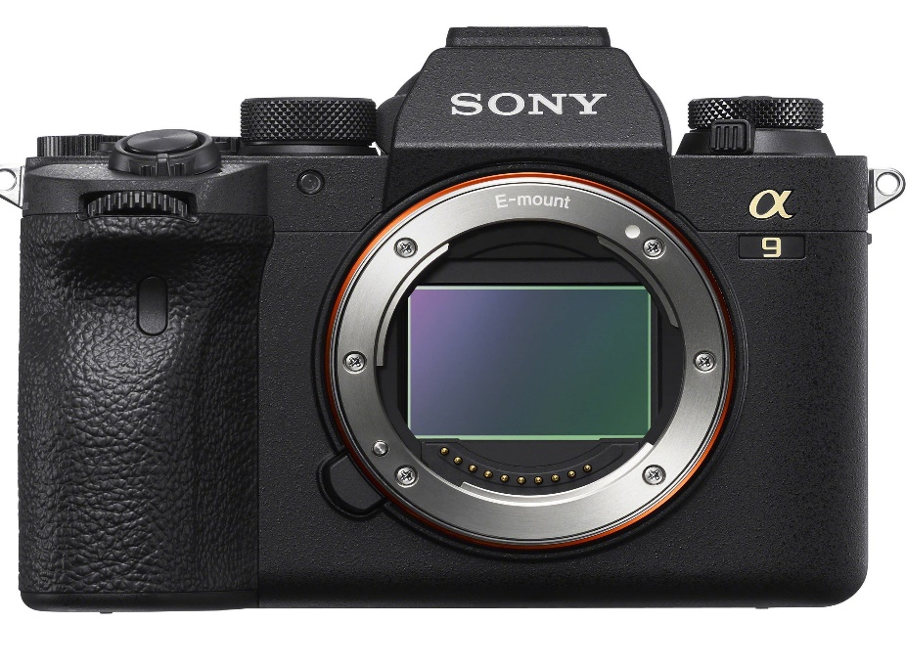

The camera features a 24.2MP Exmor RS BSI CMOS sensor coupled with the BIONZ X image processor for fast and impressive performance. With this sensor, the camera can shoot continuously at 20 frames per second with the electronic shutter or continuously shoot at 10 frames per second with the mechanical shutter. The sensor's back-illuminated design also provides high light sensitivity with ISO ranging from 100 - 51200 and expandable from 50 - 204800. This helps reduce noise creating high quality images in a variety of lighting conditions together.

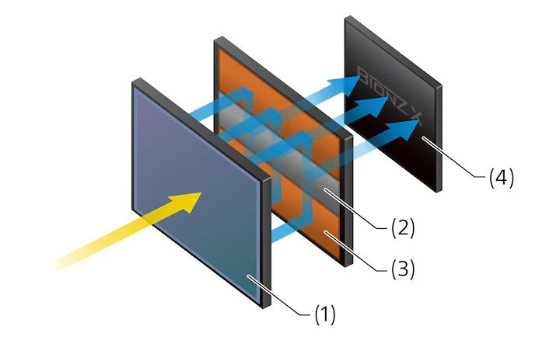

The Fast Hybrid AF system combines 693 phase-detection focus points with 425 contrast detection areas to help quickly and accurately focus on subjects in many lighting conditions. The camera integrates high-density focusing technology combined with focusing algorithms that allow detailed tracking of subject movements.

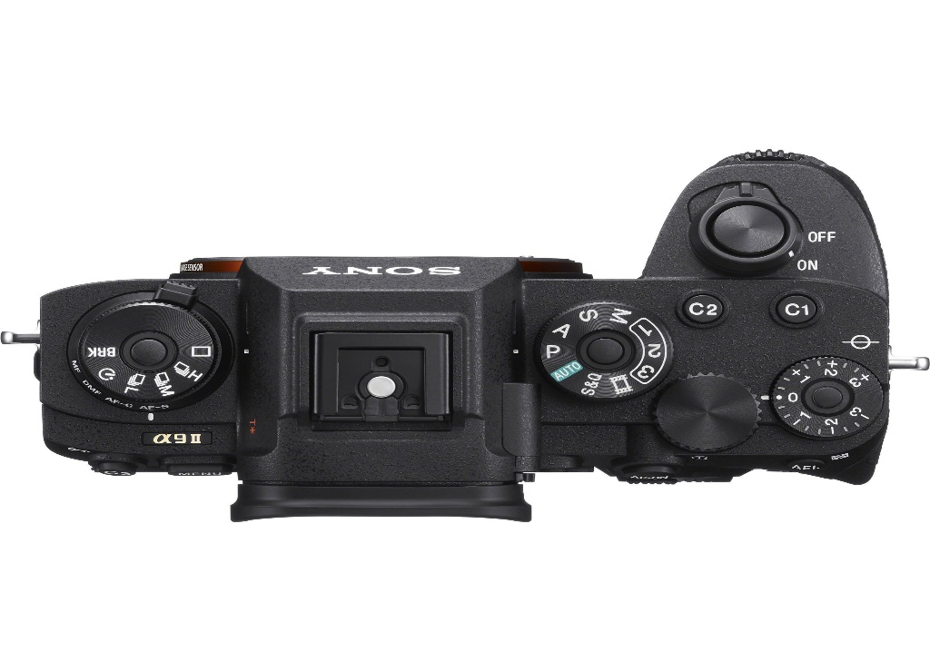

The focus system can also dynamically expand the point, using neighboring focus points to retain focus on moving subjects even when the initially selected point disappears. In particular, the system also uses many different focus functions to create highly accurate photos. Besides, the face and eye focus feature is also used to focus on the subject's eyes, suitable for both still photography and video recording. This feature can also be used when taking photos of animals as subjects.